Dynamics 365 Attachment Mover User Manual

Contents

1. Purpose 2

2. System Requirements 2

3. Approaches 2

4. Azure Blob Approach: 3

5. Intermediate Staging Entity Approach: 6

6,

# Purpose

Dynamics 365 “Attachment Migrator” is a tool that helps migrates files from local folder to Dynamics 365 (CE) as notes attachment using 3 approaches that are:

* + Azureblob Storage : Local files will be moved to Azure blob from where using Power Automate flow it will be moved to Dynamics
  + Staging Entity:Local files will be moved to a staging entity in CRM from where using Power Automate Flow it will be moved to Dynamics entity.
  + Sharepoint: Local files will be moved to a folder in Sharepoint from where using Power Automate workflow it will be moved to Dynamics.

# System Requirements

1. The local folder should contain a single json file which has the metadata containing the entity logical names, unique identifier of all the records (technically called as GUID), file name, isannotation and filefield name.
2. The documents will be uploaded based on the isannotation field:-

a. if the condition is “**True**”, the file will be uploaded to the CRM entity.

b. if the condition is “**False**”, the content of the documents will be stored in the filefield name i.e. specified in the metadata to the record an entity.

1. The user should have an active storage account in their Azure subscription.

# Approaches

|  |  |
| --- | --- |
| **Title** | **Brief Internals** |
| Azure Blob | We are uploading a file from the local folder to a storage account in Azure container using desktop tool for the console application (command prompt).  After files are moved to the azure storage account, the power automate flow will be triggered which will transfer files from azure storage container to the specific record of the entities in Dynamics 365 (CE) based on the isannotation value(True/False). |
| Intermediate Staging Entity | In this approach, we are moving files from local folder to the staging entity(Document Attachments) in Dynamics 365(CE) as records using the desktop tool for console application (Command Prompt). On the trigger of power automate flow, retrieve the notes from each record and move the attachments or store the file content in a file field to the respective record guid in an entity based on the isannotation value(True/False) |
| Sharepoint | We are moving files from a Local folder to Sharepoint library (Documents) using the desktop tool console application (Command Prompt).  Then the Power Automate flow is triggered to move the files from Sharepoint to respective records of the entity based on the isannotation field in the json to Dynamics. |

Below is the step by step guide of the approaches:

# Azure Blob Approach:

1. Create a local folder and add the files which must be moved to azure storage container. It should contain a json file which will have the metadata of the record.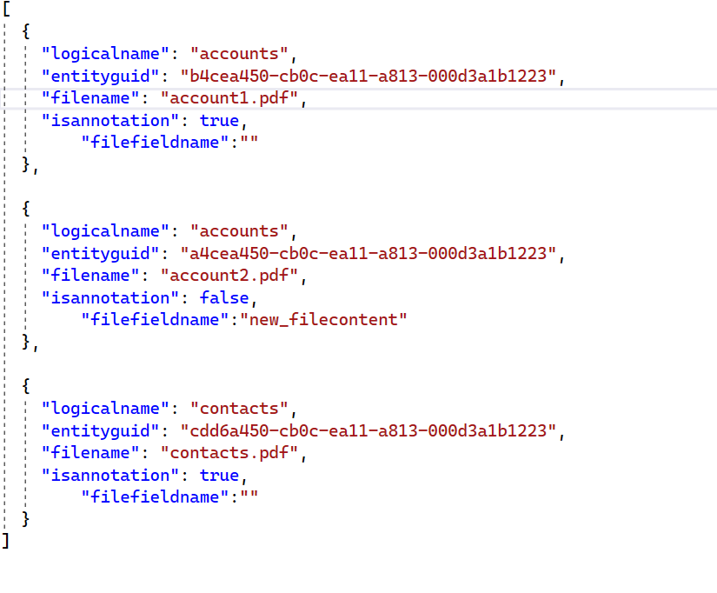

The json file should have the logical name of the record and a unique identifier which will move to the Azure container when the desktop tool is run.

The files will be moved to the CRM entity based on the annotation present in the json file (True/False)

a. If the isannotation is “True”, the documents will be attached to the notes entity under each record based on the entity logical name and guid.

b. If the isannotation is “False”, only the content of the document will be passed to the field in an entity record based on the filefield name, entity logical name and guid.

1. User should have a Azure storage account which will store the files in its storage container.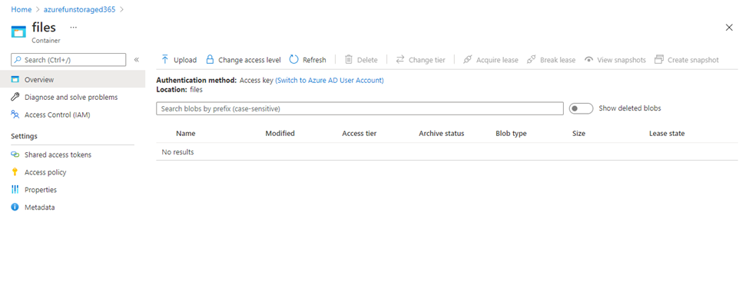
2. To move files from local folder to Azure storage container, open the command prompt to run the console application and give the command (AttachmentMover.exe) and click enter to run the application.

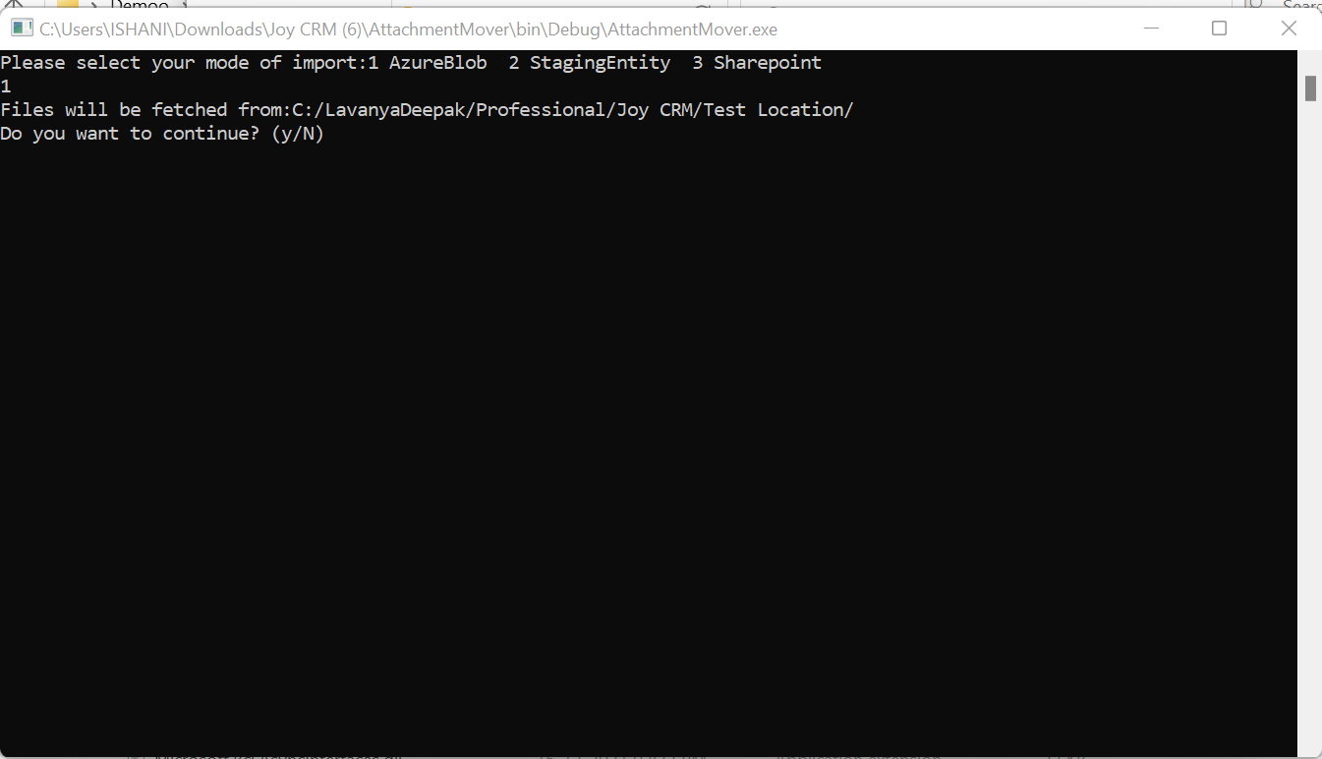

1. After running the command type “Y” and click enter to run
2. Now open the azure storage and go to azure blob storage and refresh. You can view the files which are uploaded.

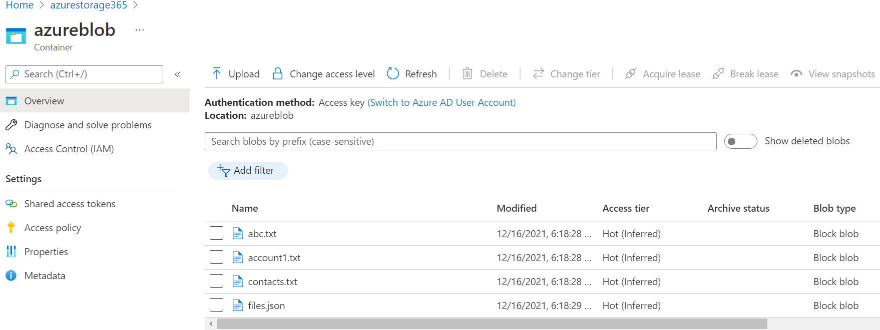

1. Open Power apps and trigger the Power Automate flow “Moving attachment from Azuer to Dynamics”

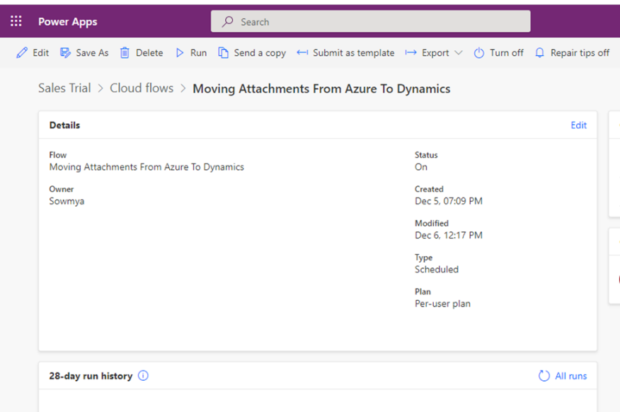

After the Power Automate flow is triggered, based on the isannotation key which is in the json file, If it is **“True”** the document will be attached to the notes based on the entity logical name and guid in Dynamics, as shown below:

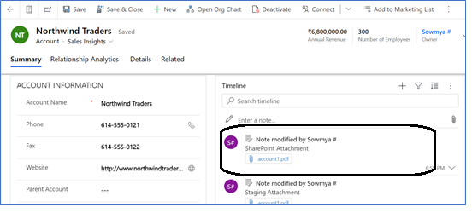

If the isannotation is “False” the contents of the document will be displayed in the field present as “Filefieldname” in the record of the entity.

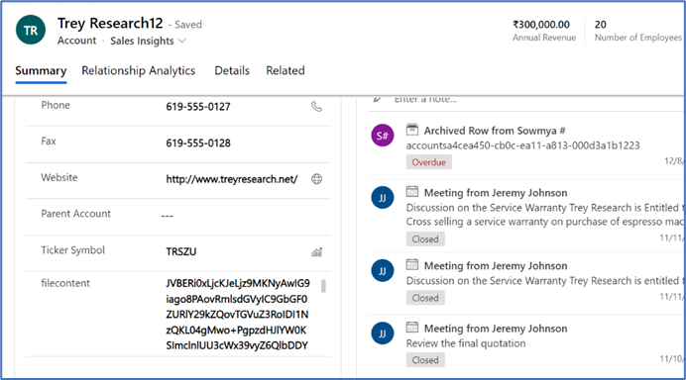

1. Intermediate Staging Entity Approach:

1. Create a local folder which will store the files along with the json file which will be moved to the staging entity in Dynamics 365.

Json file will have Json Array which has the metadata as shown below :

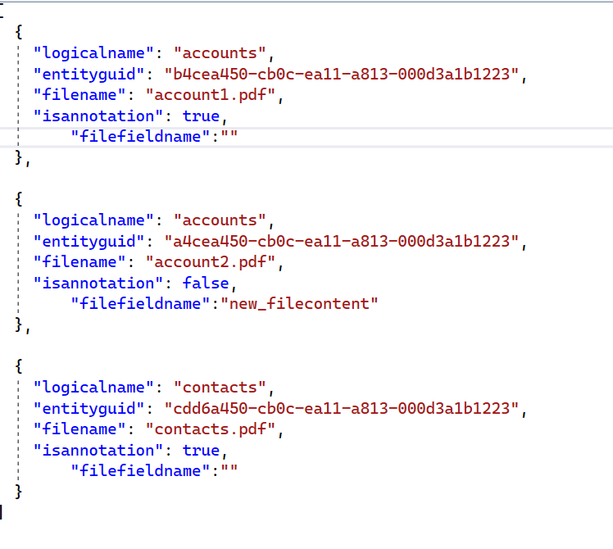

2. Open the desktop tool and select the second approach.

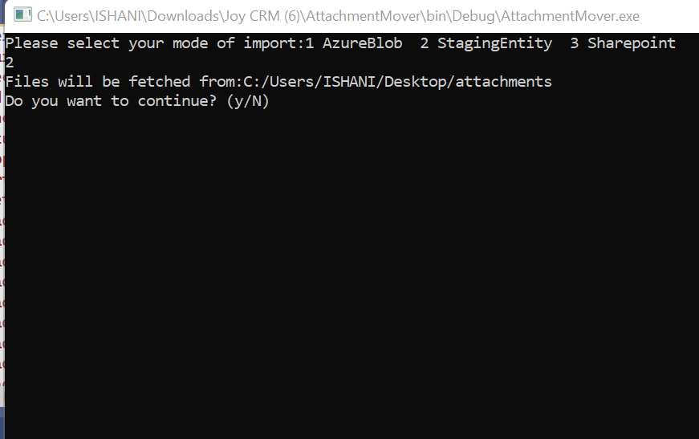

3. Type “Y” and click enter to run

4. Documents will be moved into the staging entity of dynamics and the records are created as shown below.

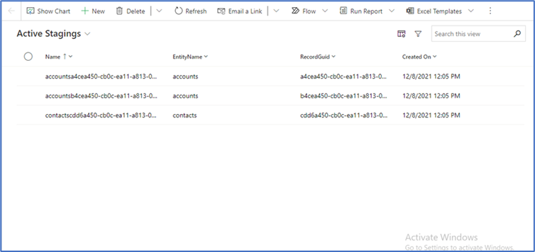

5. Each record in staging entity has the moved attachments and other fields are updated as shown below

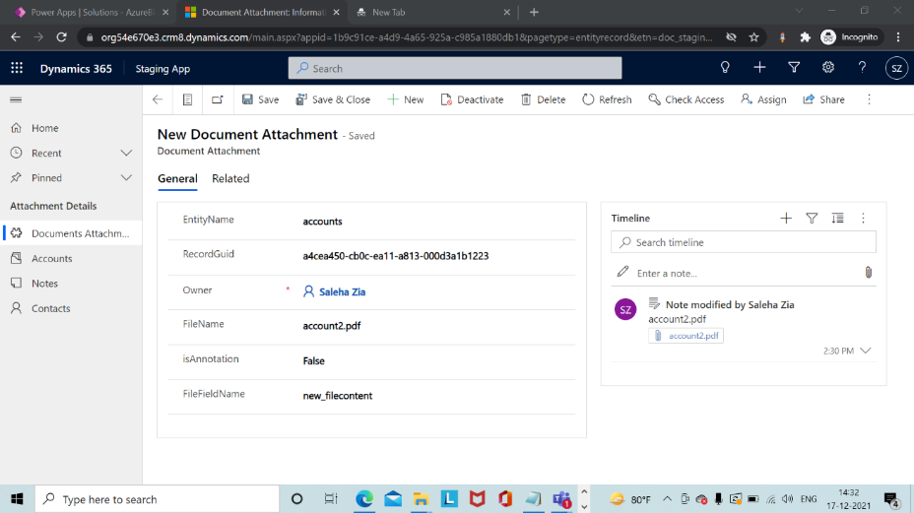

5. Open Power apps and trigger the specific Power Automate flow.

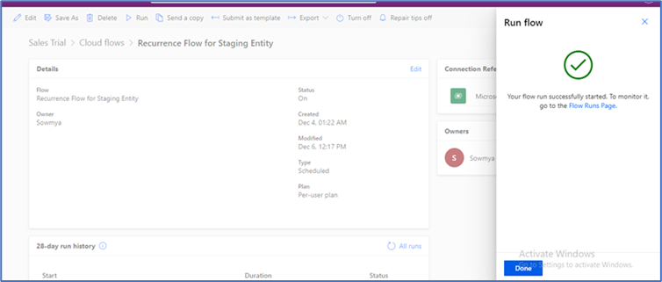

6. On the trigger of Power Automate Flow,the notes will be retrieved from each record and based on the isannotation in the json file, if the condition is “True” the document will be attached to the notes in the specific entity.

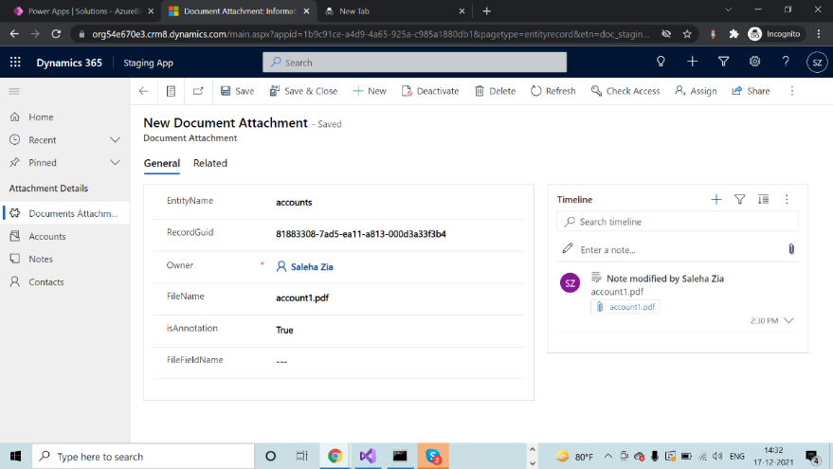

The documents is attached to the entity as shown below:



If the condition is “False” the contents of the document will be displayed in the field present as “Filefieldname” in the record of the entity.

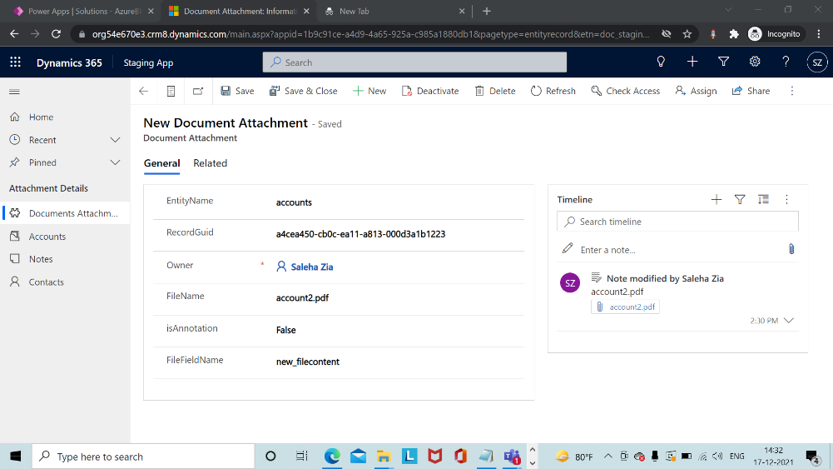

As per the below picture, the contents of the file is present:

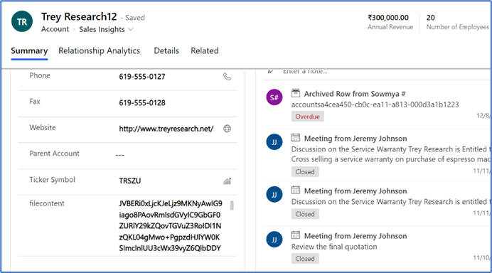

6. Sharepoint Approach:

In this approach the files will be moved from a local folder to a Sharepoint folder and then using the power automate flow the file will be migrated to the CRM entity.

1. Create a local folder which contains the files to be migrated to the CRM entity along with a json file which contains the metadata of all the files.

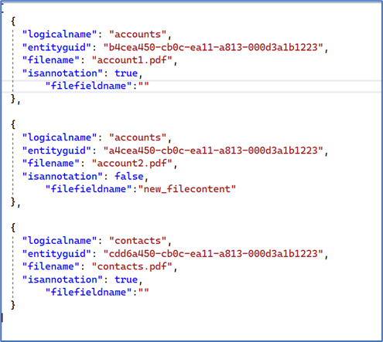

2. Next open the console app and run proper command to fetch the items from local folder to the Sharepoint.

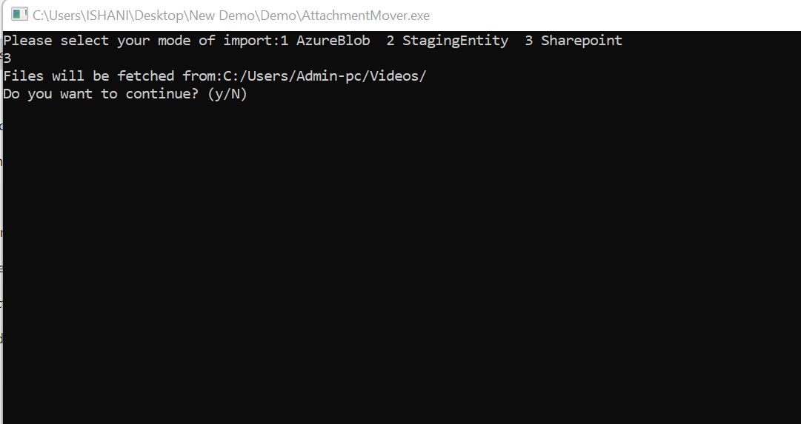

After the program runs successfully, the documents will be viewed in the Sharepoint folder like shown below.

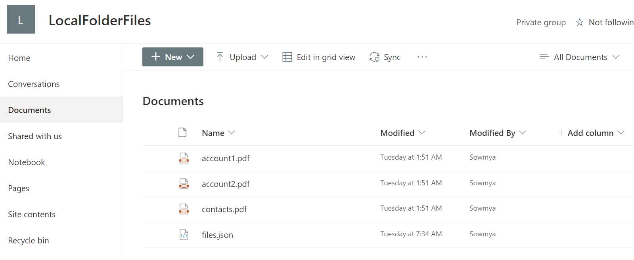

3. Open the Power Apps and trigger the Power automate flow. After flow runs successfully, the files will be moved to the specific entity in the CRM.

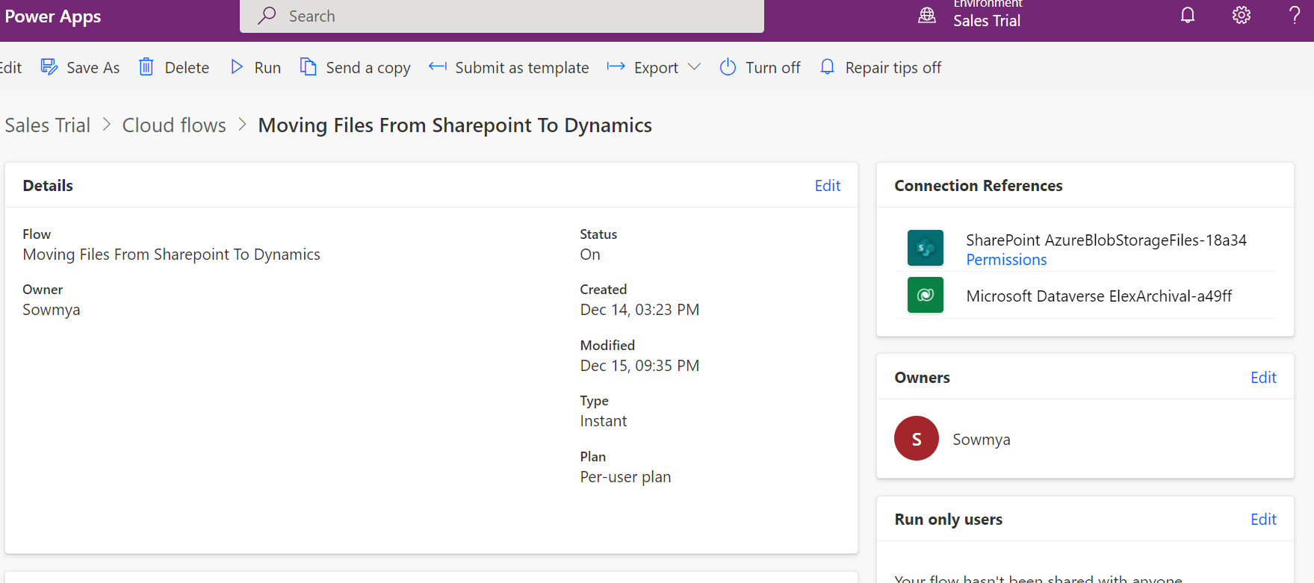

Based on the isannotation present in the json, if the condition is “True” the attachments will be moved to the notes, shown below:

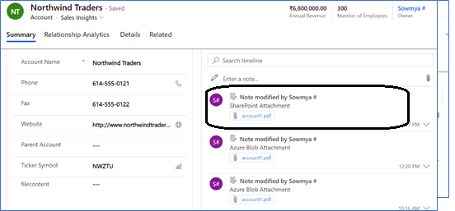

If the condition is “False” then the content of the file is moved to the file field present in the entity, as shown below:

